Names:
Hour:

The Creation of the Constitution

Part 1
Watch the following video for an overview of James Madison and the Creation of the Constitution.
Sign into BrainPop with Carthage as UserName and tigers as the password
http://www.brainpop.com/socialstudies/famoushistoricalfigures/jamesmadison/

Part 2

Using search engines type your answers to these questions using complete sentences and with a different color font.
Do not copy and paste your answers from the internet.
Write all answers in your own words.

- What does the word “Constitution” mean?

- What does the word “Framer” mean in relation to the Constitution?

- What is a “Delegate”?

- How many Delegates were at the Constitutional Convention?

- Where was the Constitutional Convention held?

- Who was the oldest Delegate? How old was he?

- Who was the youngest Delegate? How old was he?

- Who was chosen to be the president of the Constitutional Convention?

- Who was called the "Sage of the Constitutional Convention"?

- Who was called the "Father of the Constitution"?

Explain the following terms using the picture below: 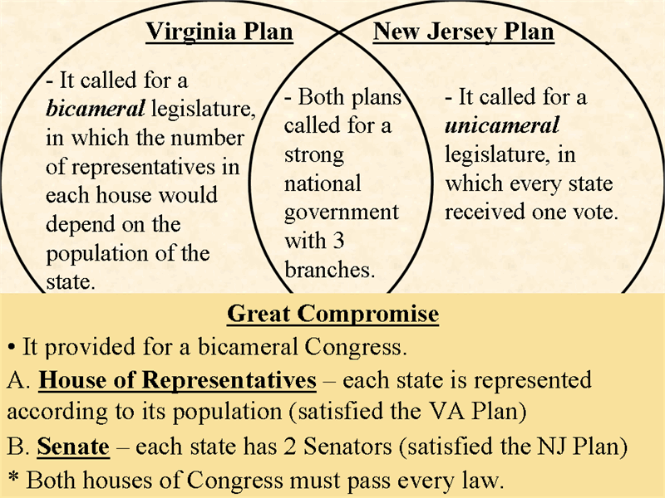
New Jersey Plan
Virginia Plan
Great Compromise

Part 3
Reading a Chart
The Articles of Confederation and the Constitution
The chart below lists features of government under the Articles of Confederation and
under the Constitution.
Directions: Look over the chart and answer the 3 questions below.

Articles of Confederation | Constitution
Only a loose agreement among the states;  power was in each state. | A formal union; power was centered in the  national government.
A one-house Congress, with one vote per  state, no matter what its population. | A two-house Congress; the House of  Representatives based on population and  the Senate based on equal representation—  two votes per state.
Congress had no power to tax. | Congress could tax.
Congress could not regulate foreign or  interstate trade. | Congress could regulate foreign and  interstate trade.
No executive to enforce laws made by  Congress. | An executive branch led by the President  could carry out and enforce national laws.
No national system of courts. | A judicial branch, with a supreme court, to  review laws and settle interstate conflicts.

1. How was the change in Congress under the Constitution an improvement?

- What were two changes in the powers of Congress?
- Draw Inferences Why was it important to have a judicial branch at the national
level?

Part 4

Chapter 7
Use your online textbook and Chapter 7 Section 3 to fill out the following chart:
Many states believed that a bill of rights was essential to protect basic
and to protect against abuses by the .
• First Amendment: guarantees freedom of , , and
.
• Second Amendment: deals with the right to .
• Third Amendment: bars Congress from .
• Fourth Amendment: protects citizens from
or .
• Fifth through Eighth Amendments: protect citizens who are
.
• Ninth and Tenth Amendments: limit the powers of the
to those granted in the .
The Bill of Rights
• Approval needed from states before the Constitution could go into
effect.
• Importance of Massachusetts: Antifederalists hoped it would reject the Constitution
because opposition was strong where Shays’ Rebellion had occurred. It was approved
after a major campaign by the Federalists.
• Importance of Virginia: Virginia was and . If it rejected the
Constitution, and other states might do so, too.
Federalists
Leaders: 1. John Jay, 2. , 3.
Position on the new Constitution:
Main argument for position: need for a central government
Antifederalists
Leaders: 1. Patrick Henry, 2.
Position on the new Constitution:
Arguments for position:
1.
2.
3. The President could become like a king by being repeatedly reelected.

The Ratification Debate
Federalists Versus Antifederalists

Part 5
Watch the Constitution video in the following location:
My Computer – Video – Crigger – Constitution

