Names:
Hour:
The Oregon Trail
From: http://mrkash.com/activities/oregontrail.html
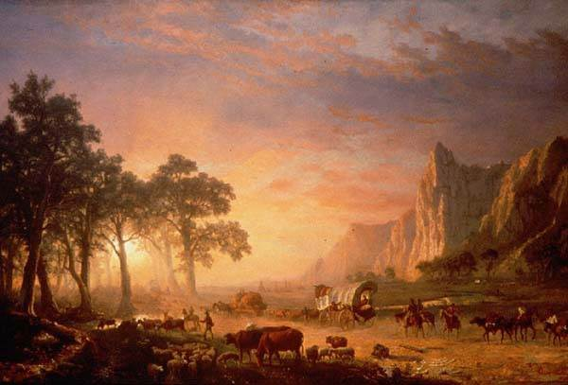
Directions: Click on the sites indicated to find the answers.
Answer the questions using complete sentences and change the color of your answers.

http://www.america101.us/trail/Introduction.html
1. Why was the Oregon Trail important?
2. How many people in ten died on the trail?
3. What were the real enemies of the pioneers on the trail?
4. Who were the first people to travel by covered wagon to Oregon?
5. How many people traveled on the Oregon Trail?
http://www.america101.us/trail/Jumpingoff.html
6. What river did most people start their journey to Oregon on?
7. Why did the emigrants have to wait for the grass to grow?
8. What supplies did the emigrants need to bring with them?
9. Why did the emigrants use farm wagons on their trip?
10. What type of things did the emigrants throw out after they realized they had too much?

http://www.america101.us/trail/routewest.html
11. How many miles was the trip to Oregon?
12. How long did the sea journey to Oregon take?
13. How long did the journey by wagon to Oregon take?
14. What river does the Oregon Trail follow?

15. Click on http://www.america101.us/trail/Facts.html
Click on two of the Fantastic Facts and write a short summary about each.
http://www.america101.us/trail/Power.html
16. Why were horses not used to pull the wagons?
17. Why were Oxen the most popular animal to pull the wagons on the trail?
18. Why were Mules not used to pull the wagons?
http://www.america101.us/trail/Hardships.html
19. How many people drowned in 1850 attempting to cross the Green River.
20. Explain two other hardships travelers might face on the trail.
http://www.america101.us/trail/buffalo.html
21. What would travelers burn to stay warm?
http://www.america101.us/trail/Native.html
22. In your own words, explain what happened at the Grattan Massacre.
23. How many Mormons moved west on the trails?
24. Where did they end up?
25. Why did the Mormons move west?
26. Who was the founder of the Mormon church?
27. Who led the Mormons west in 1846?

