Unit 5 Timeline

Task:
Today we will begin creating timelines covering the main events covered in Unit 5 of our Textbook.

Process:
- Go to http://www.timetoast.com
- Click on Sign Up.
- Write one of your numbers as the username
- Use your number@r9tigermail.org
- Use your birthday as your password.
- Agree to the Terms and Conditions.
- Click Sign-Up
- Open you Tiger Mail click on the confirmation link. If you did not receive an email, go back and make sure you wrote everything correct in your email. Remember @r9tigermail.org
- Make sure you are signed in and click “create new timeline.”

Requirements:
- You need to include these 10 events:
  - Fugitive Slave Act
  - Kansas-Nebraska Act
  - Election of 1860
  - Battle at Fort Sumter (Civil War Begins)
  - The Monitor vs. The Merrimack
  - The Battle of Shiloh
  - The Emancipation Proclamation
  - The Battle of Gettysburg
  - Surrender at Appomattox
  - The Thirteenth Amendment

Each event must include the following:
- A title
- The Date in which it happened
- An appropriate picture
- A link to a website about it
- A definition or summary of the event (Needs to be in complete sentences)
- Do not copy and paste this information from the Internet.
(If I find any copy and pasted material you will receive a zero for the entire assignment)
Make sure you set your timeline to have an appropriate timespan, meaning the years before 1850 or after 1865 should not be on your timeline.

When you think you are finished, make sure your timeline is visual
and paste your link into Google Classroom

Grading Rubric

Title | 2 Point
Correct Time span (1850-1865) | 3 Points
For each event
(Ten Total Events)
Title | 1 Point
Correct Date | 1 Point
Description of Event | 1 Point
Working Link to a Related Website | 1 Point
Picture of Event | 1 Point
Total Points for Timeline | 55 Points

Make sure your timeline is visible before you turn it in.
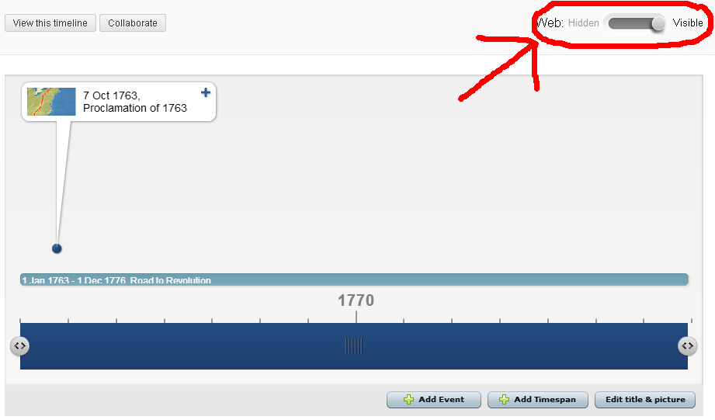
Example of an entry
