Where in the World?
Directions: Read each statement below. Each statement or picture describes a natural or manmade landmark someplace in the world. As you read each statement, ask yourself what are the key words in the statement? Use search engines -- and those key words -- to figure out which landmark each statement describes.
1. This building, which took over 10 million bricks to build, is still the tallest building in New York City even though it was built in 1931.
2. This location in London is home to the Queen of England.
3. This natural feature is 6,000 feet deep and located in Arizona.
4. When this building was built in 1889 it was the largest building in the world. Today it is seen as the symbol of Paris, France.
5. This was a gift from the French to the people of the United States in 1886
6. This chapel is home to amazing works of art by such artists as Michelangelo, Sandro Botticelli, Pietro Perugino and Pinturicchio.
7. This is the name given to the three waterfalls (Horseshoe Falls, American Falls and the Bridal Veil Falls) located on the American/Canadian border.
8. Where are the statues in this picture located? (Use descriptive words to search for the location)
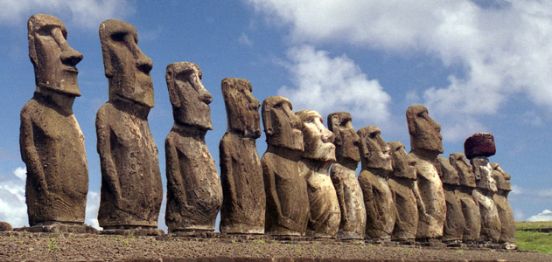
9. This landmark located in South Dakota was originally planned to include the upper bodies as well as the heads of 4 American Presidents.
10. Large audiences would watch various sporting events in this amphitheater built around 75 A.D. in Rome.
11. What country would you have to visit to see the tallest waterfalls in the world?
12. The most famous “island prison” is located close to San Francisco, California, what is its name?
13. This monument was built in 1965 and is known as the gateway to the west.
14. This was built between 220 BC and 206 BC to protect the people of China from outside attackers.
15Where was this picture taken?
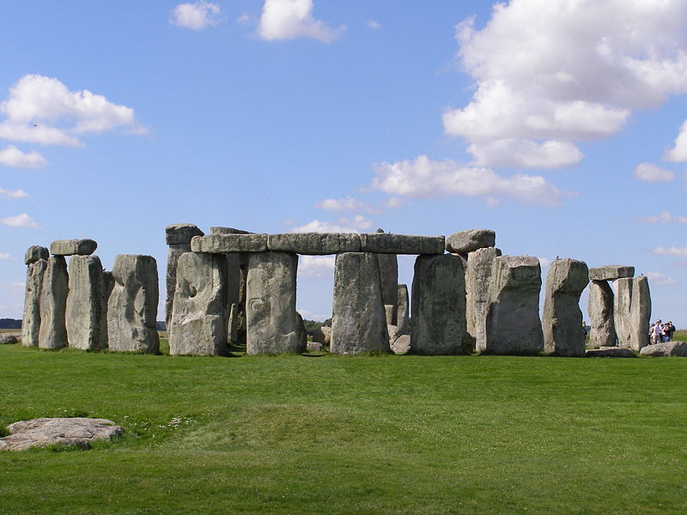
16. This is hottest desert in the world which covers most of North Africa.
17. Gondolas are often used as a form of travel in this city in Italy.
18. This tower was originally built to be vertical, but over time is has started leaning.
19. Located in Greece, this temple was built to honor the Greek goddess of heroic endeavor.
20. What is unique about how “Petra” was built?
21. What is the only remaining wonder of the Seven Wonders of the Ancient World?
22. This location covers most of the Amazon Basin of South America. There are more than 2.5 million different insect species living here.
23. What natural phenomenon is shown in this picture?
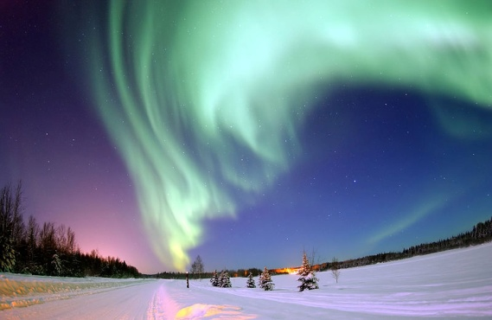
24. In 1953, Edmund Hillary and Tenzing Norway were the first two people to stand at the top of this mountain.
25. What is the Burj Khalifa and why is it important?
26. What connects the Atlantic Ocean to the Mediterranean Sea?
27. Where is the Hall of Mirrors located?
28. What mausoleum is pictured below?
